SCHOOL PICTURE CAN GO HERE SO IF AT A CAMP EVERYONE IS EVERYWHERE OF WHAT THIS CHILD LOOKS LIKE. | NAME  Type-1 Diabetes Medical Management Quick Reference  DOB M/D/Y  Call any time with questions or concerns.  Moms Name (mom) phone number  Dads Name (dad) phone number  In case of emergency, call 911 first.
Check BG and Bolus | Before breakfast, snack, lunch, & dinner
OTHER TIMES TO DO FINGER POKES FOR BG | Before PE, an hr after PE & before bedtime, feeling low/ high (dizzy, confused, crabby, foggy brain)
CHANGE INSULIN POD & INSULIN | (child’s name) can change his insulin pod independently incase it falls off. Otherwise it is changed every 3 days (filled with 125 units)
SUPPLIES  Childs Name should wear his/her pump AT ALL TIMES and will have sport backpack with the following items | ALWAYS have glucose meter, finger poker, testing strips, water, and fast-acting sugar (juice, soda, candy, glucose tabs, etc.) in increments of ~15g of carbs on hand.  Do not use low-carb/sugar free items to treat a low.
DO NOT LEAVE Childs Name ALONE WITH  LOW BLOOD SUGAR (<80).  TREAT WITH JUICE/ FOOD AND RECHECK AFTER 20 MINUTES. |  | (>200) HE/ SHE MUST TAKE A BREAK & DRINK WATER. CORRECT WITH INSULIN USING 1 UNIT OF INSULIN FOR EVER 70 OVER. RECHECK AFTER 2 HOURS. IF STILL ABOVE 200 AFTER 1 CORRECTION AND 2 HOURS CALL PARENTS.
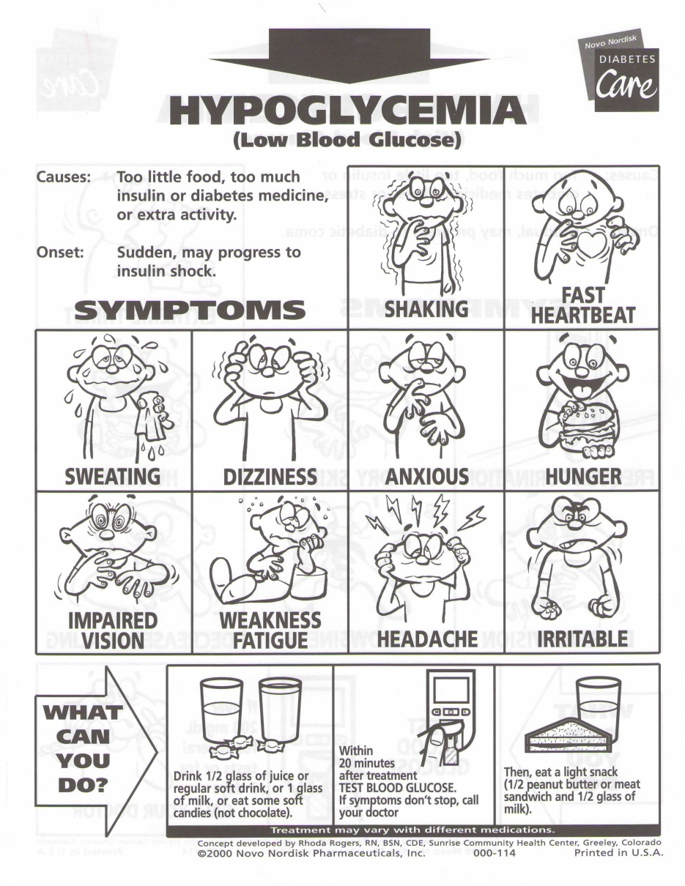 |  | 